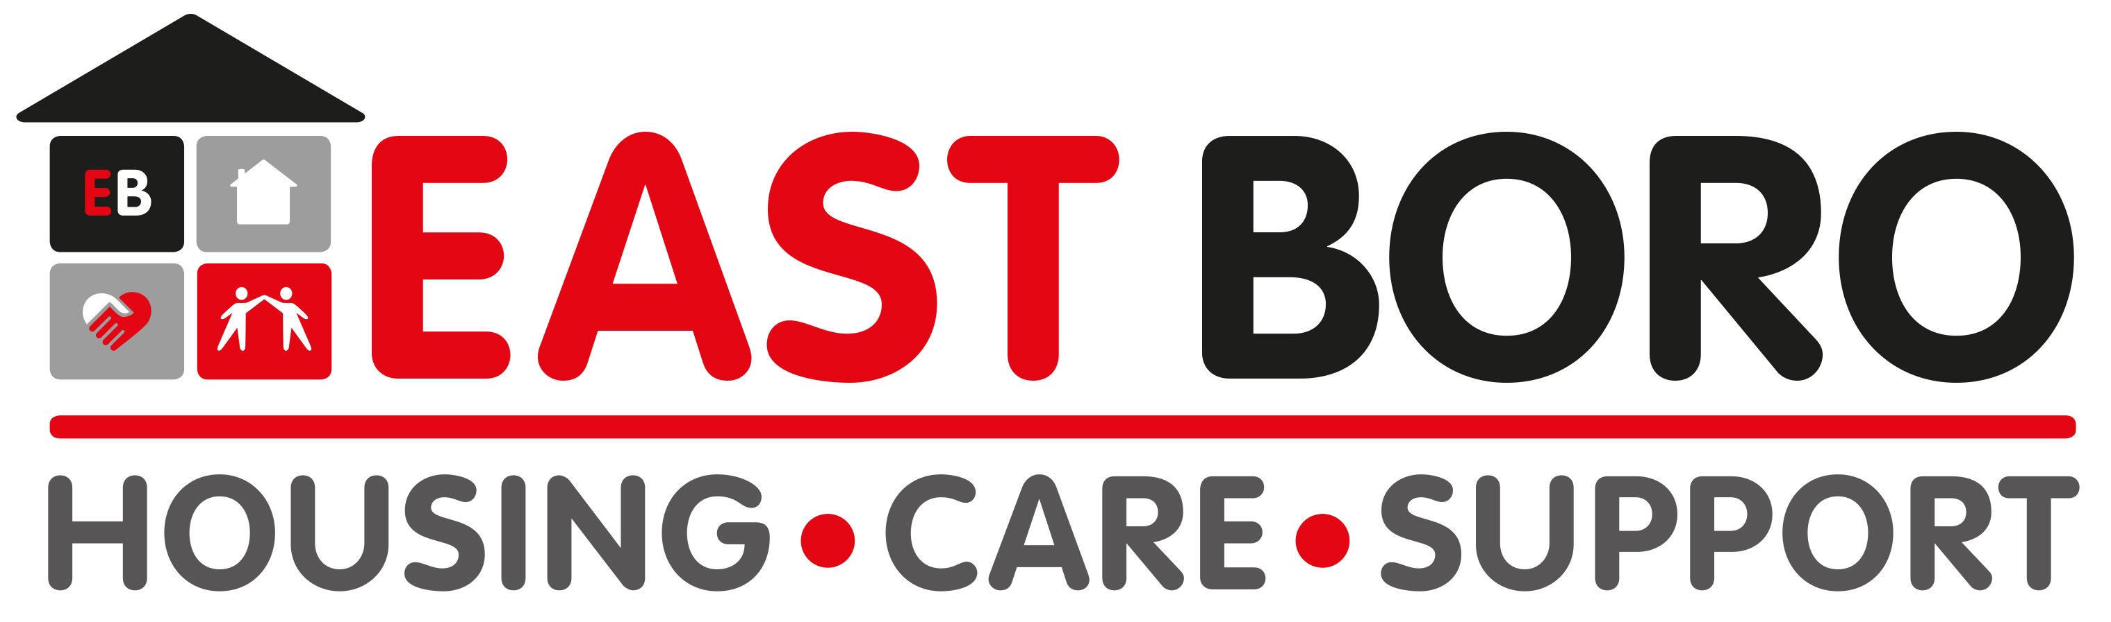 | NEWS RELEASE  For general release

Date: 31 March 2020

Aster Group and East Boro Housing Trust complete partnership

Housing associations, Aster Group and East Boro Housing Trust, (East Boro) have today (31 March 2020) completed their partnership agreement.

The new partnership will enable the two organisations to increase their capacity to build homes, invest in their communities and provide customers with increased efficiencies and an enhanced digital offer.

Aster and East Boro – which build, own and manage homes across the south of England – announced their intention to form a partnership in November 2019 before entering a six-week consultation period with shareholders.

The completion of the partnership sees East Boro become part of Aster Group while retaining its brand, board and stock. There will be no interruption to the services provided by the organisations to their customers and no change to the roles of employees.

The partnership adds the 427 homes owned and managed by East Boro to Aster’s nearly 30,000-home portfolio.

Bjorn Howard, group CEO of Aster Group, said: “There are huge challenges facing the UK to improve the housing market to make it fairer, more efficient and more accessible. We are determined to play our part in the solution to these challenges.

“By joining together, we increase our ability to build more homes and invest further in our communities. It also means we can strengthen our resilience as an enlarged business to provide greater continuity and certainty, not only to our customers, but our colleagues too.

“Importantly, the successful creation of this partnership puts our combined group in the position to be able to help other smaller housing associations in the future unlock greater development capacity in the sector meaning even more people will have high quality affordable homes.”

Kevin Hodder, CEO of East Boro Housing Trust, added: “The aim of this new partnership is to play to the strengths of both organisations. I’m proud to say that East Boro’s strong brand and ethos will remain and continue to thrive with our customers remaining at heart of every decision we make. While customers and colleagues won’t see any immediate changes, the long-term improvements in their experience will be significant. Together with Aster, we will be able to further invest in enhancing digital services, innovation and new technologies along with providing our colleagues with a wider range of development opportunities.”

East Boro was founded in 1960 and is based in Wimborne, Dorset. Aster owns and manages social rent, affordable and shared ownership homes in 11 counties across the south of England (Berkshire, Cornwall, Devon, Dorset, Somerset, Gloucestershire, Hampshire, Oxfordshire, Surrey, Sussex, Wiltshire).

ENDS

Notes to editors
Aster Group supplies a wide range of housing options in response to the housing crisis, working towards its vision of ensuring everyone has a home. The not-for-dividend business was established in 1990 and has over £1.7billion worth of assets. Aster plans to invest £2 billion over seven years on over 10,700 new homes. Aster forecasts delivering just under 1,000 homes during the next financial year (2019/20). The group reinvests profits from open market sale and shared ownership to support the development of affordable homes. It owns and maintains over 31,000 homes, provides services to approximately 90,000 customers and employs 1,200 people. Aster Group’s corporate social responsibility commitments set out the additional work the business chooses to do. For more information, visit www.aster.co.uk.

Follow us on Facebook: AsterGroupUK
Twitter: @AsterGroupUK

